Group 17 Practical 5

**Task 2**

1. This is what we did to safeguard our website against loss of availability through SQL injection:

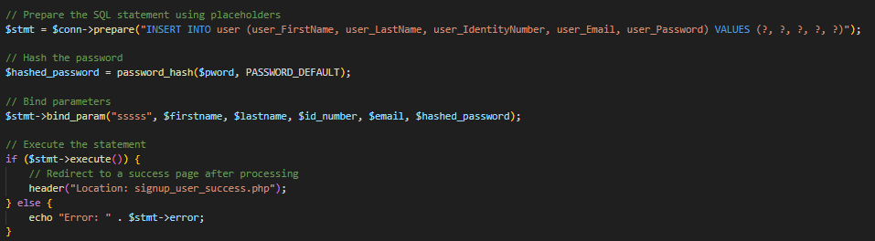

1. This is what we did to safeguard our website against loss of confidentiality through XXS:



This is for the when the user signs up to our website

1. P’
2. Kl.
3. L;m’

**Task 3**

1. Dfswg
2. We used HTML to structure our website. Basically, we used HTML as the skeleton of the website.
3. Dgsv
4. dgs